LeetCode Program 2413
Link :- https://leetcode.com/problems/smallest-even-multiple/
Successful Submission
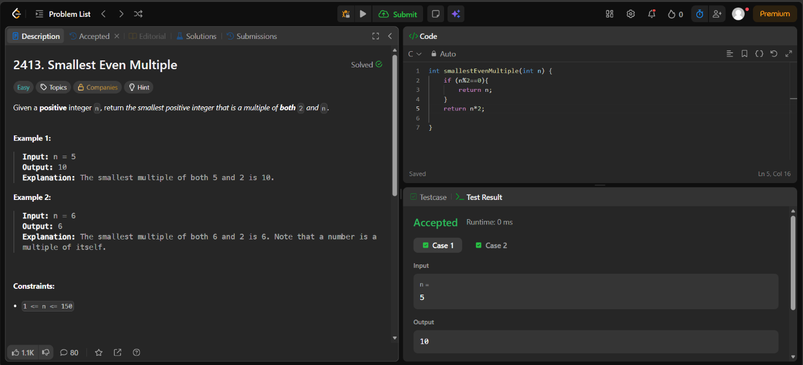
Source Code


